* Discussion of Wii U continues
* Knockback
* Block
* Attack

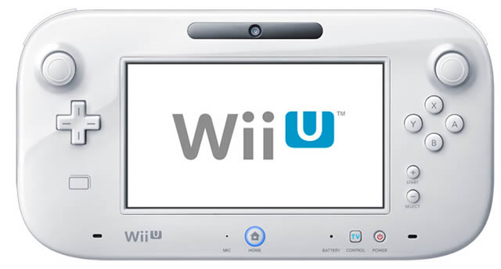

* Vertical Slice-

1. Village Whiteboxing
2. state machine to determine whether units are with ganon or are free
3. Hit collider for swordplay in terms of 3d gameplay
4. Sword Swing animation? Vector Math? Sword with no Collider? Hit something plays response

* Focus on primitively showing the gameplay rather than art. To demonstrate the gameplay. Utilize capsules and cubes
* Functional Specifications:

1. HUD
2. Menu
3. Combat
4. Units+Unit Management

Ganondorf Command Notes:

Selection, target raycast out to unit and that would determine and show that all the units of the same kind within the radius would convert to energy and head towards the player.

Determined by Raycast and Radius of units.

Aim at units by pressing right trigger which activates sphere collider and every unit of the same kind would be glowing.

Lower right hand side HUD would display half opacity the unit that was going to be selected to preview that the unit that was going to be selected.

Possible instantiation of a spotlight

Absorption. Destroy the unit there then they change to particle effect that moves towards the player. Could just change their state in the state machine so that they get absorbed and they become a particle effect that changes to absorb then when instantiated they are changed back into their normal state.

HUD functional specification- Steven

UI, State Machine- Michael

Kenneth-UI Functional Spec

ED - Scaling